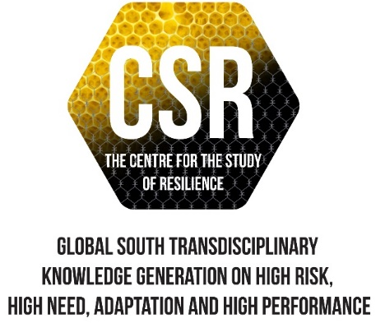

SENTRUM VIR VEERKRAGTIGHEIDSTUDIES

WA SENTHARA YA TWANTŠHO

**COVER LETTER**

1. **AUTHOR**

**Prof Liesel Ebersöhn**

Director: Centre for the Study of Resilience

Secretary General: World Education Research Association

Full Professor: Department of Educational Psychology

Faculty of Education

University of Pretoria

1. **CONTACT DETAILS**

* **E-mail:** [liesel.ebersohn@up.ac.za](mailto:liesel.ebersohn@up.ac.za)
* **Tel:** +27 12 4202337
* **Fax:** +27 12 4205511
* ORCiD iD: 0000-0002-2616-4973

1. **POSTAL ADDRESS**

Department of Educational Psychology  
Faculty of Education  
University of Pretoria  
Groenkloof Campus  
C/o George Storrar/ Leyds street  
Pretoria

0002

1. **MANUSCRIPT DETAILS**

* **Manuscript title**: Training Educational Psychologists for Work Engagement in a context of inequality and trauma in South Africa
* **Page count:** 34
* **Word count**: 8 537
* **Figure count**: 35
* **Table count**: 1

1. **DECLARATION**

Declaration the manuscript is original, not previously published, and not under concurrent consideration elsewhere. Furthermore, there are no existence of any similar published manuscripts written by the author.

Kind regards



Prof Liesel Ebersöhn

Secretary General: World Education Research Association

Director: Centre for the Study of Resilience

Full Professor: Department of Educational Psychology

Faculty of Education

University of Pretoria

Pretoria

0002

liesel.ebersohn@up.ac.za

+27 12 4202337