30 May 2021

**The editor**

**South African Journal of Education**

Dear Editor

**SUBMISSION OF ARTICLE**

I hereby confirm that the attached article ‘Identifying the factors impacting the uptake of Educational Technology in South African Schools: A Systematic Review” is my own, original work and has not been previously published. It is not under consideration elsewhere.

Kind regards,

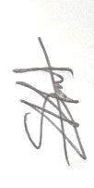

S Hart

072 436 6770

samantha.ane.hart@gmail.com