1. **Declaration of Manuscript not published nor is this manuscript before review at any journal.**

**The sustainability of Information Communication Technology (ICT) in previously disadvantaged public schools in Gauteng, South Africa**

Mrs. Kharoon Nisha Rasool

(PhD candidate at the University of Johannesburg, South Africa)

[Khairoonrasool5@gmail.com](mailto:Khairoonrasool5@gmail.com)

Dr. Parvathy Naidoo (corresponding author)

(Senior Lecturer at the University of Johannesburg, South Africa)

[pnaidoo@uj.ac.za](mailto:pnaidoo@uj.ac.za)

1. **Turnitin Similarity Index = 3% (full report is available upon request.**

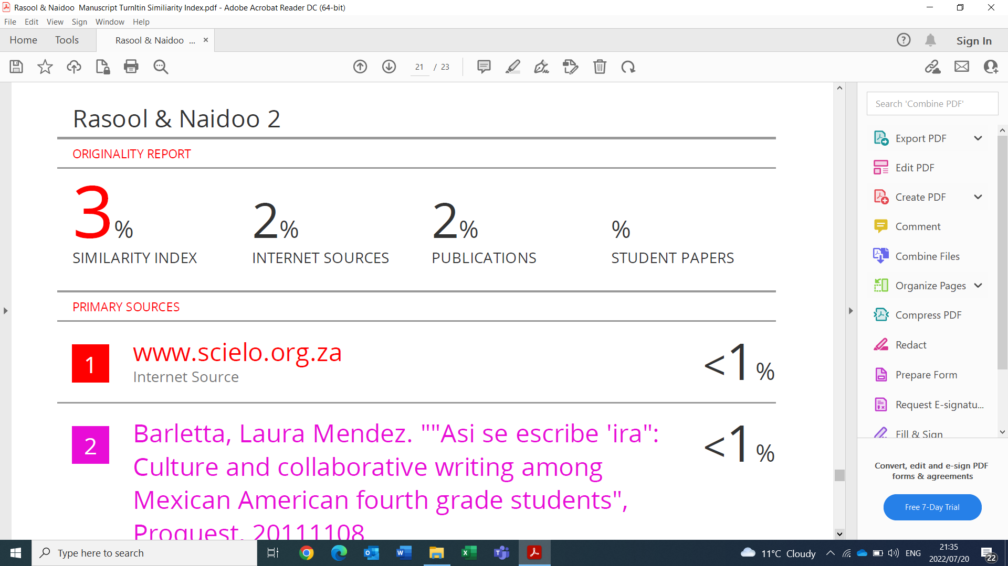

 Dr Parvathy Naidoo